8-12-2025: Meeting with Christian and Emilie
Question: At what coverage is it not worth/cost-effective to distribute nets anymore? (due to community effect)
- Is there any community effect when protected by nets? How much is it?
  - Overall prevalence reduction - prevalence reduction in users only
Answer:
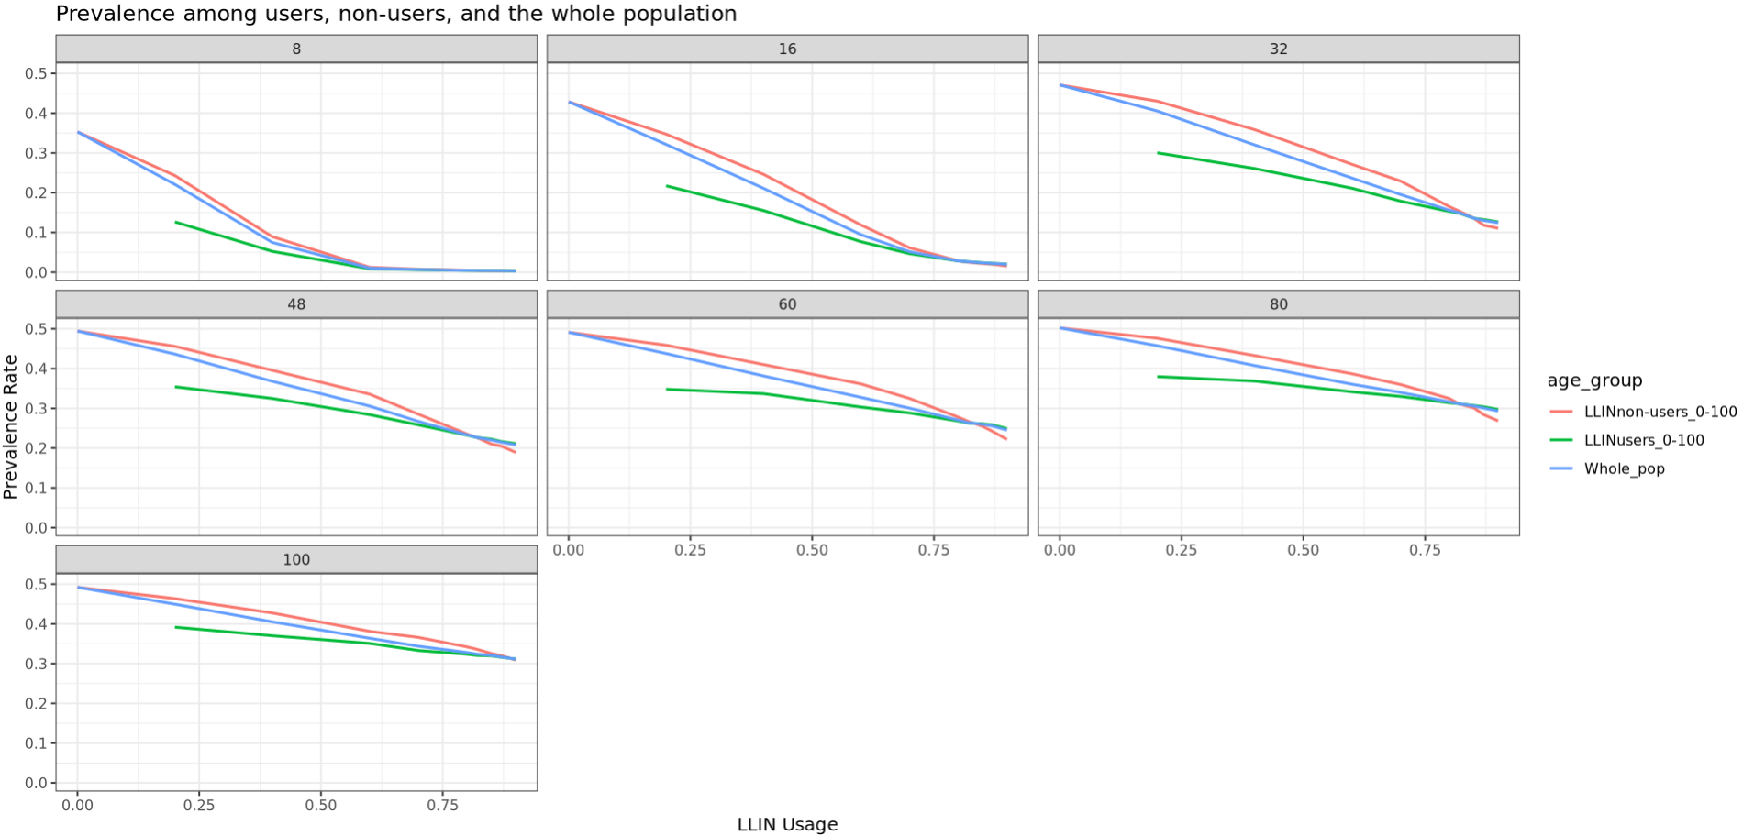
- How does this community effect vary with coverage?
- Answer:
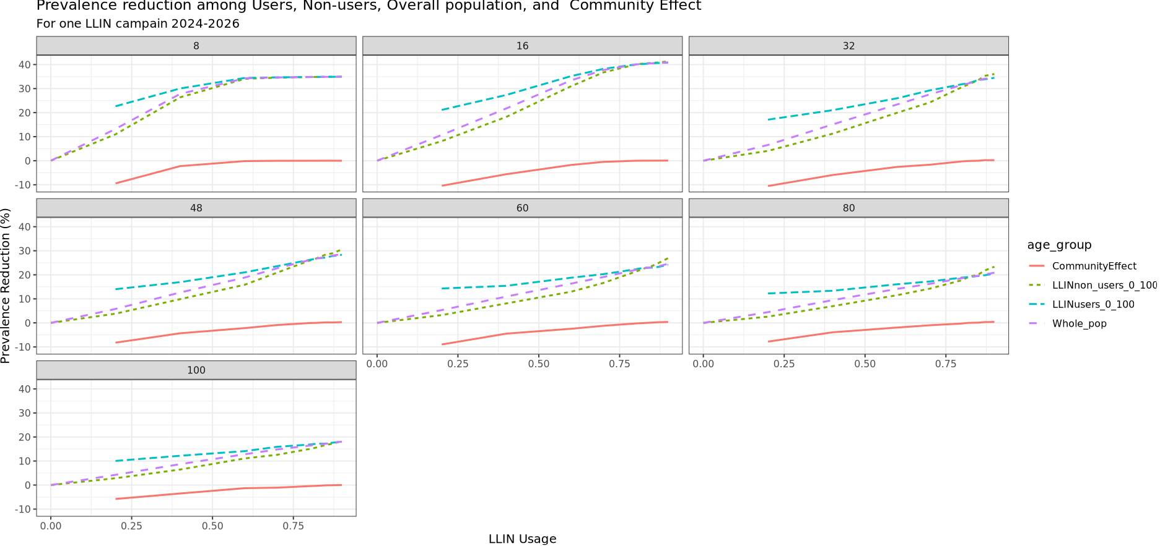

- How does this community effect vary with transmission intensity/EIR? => what is the coverage needed to achieve an impact of 10 or 20% reduction in prevalence among non-users?, varying with EIR?
Answer:
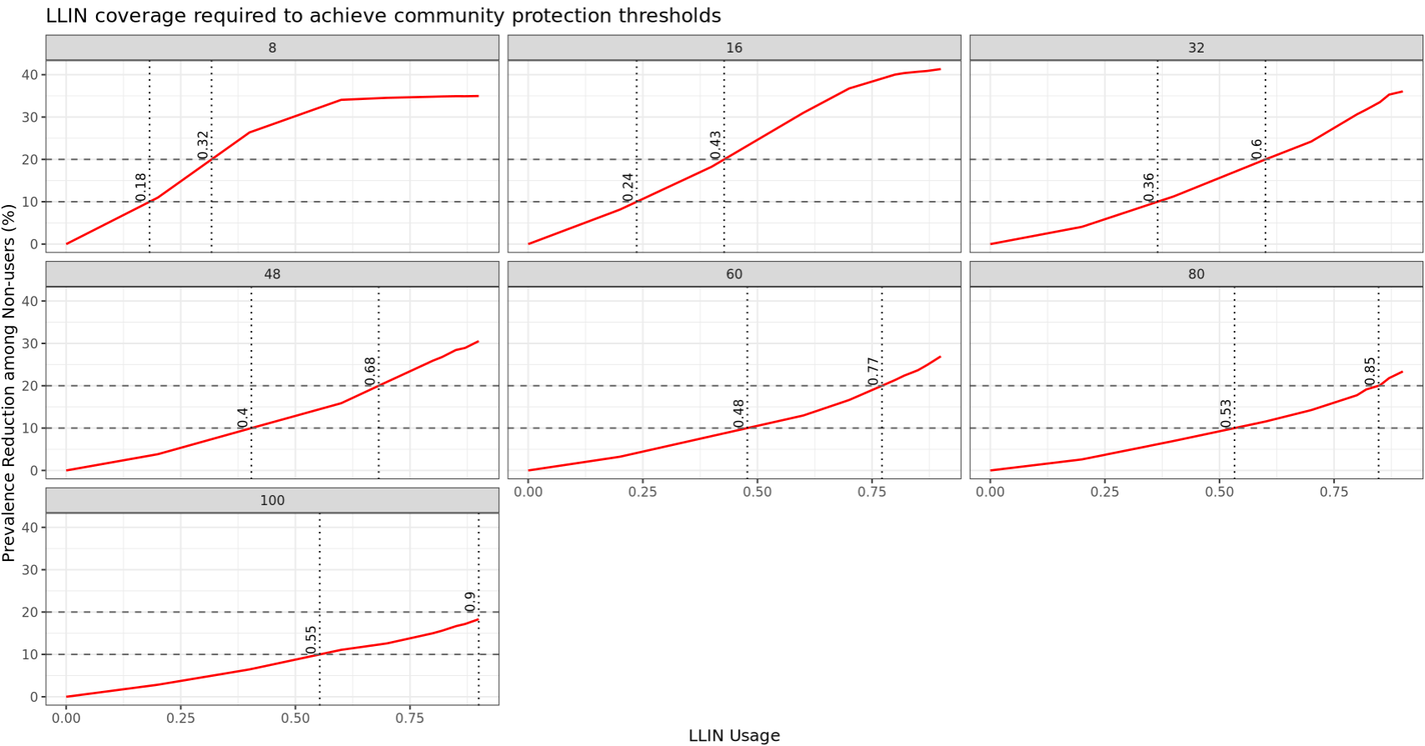At high EIR (eg, 100), 20% reduction among non-users may be unattainable, even at high coverage
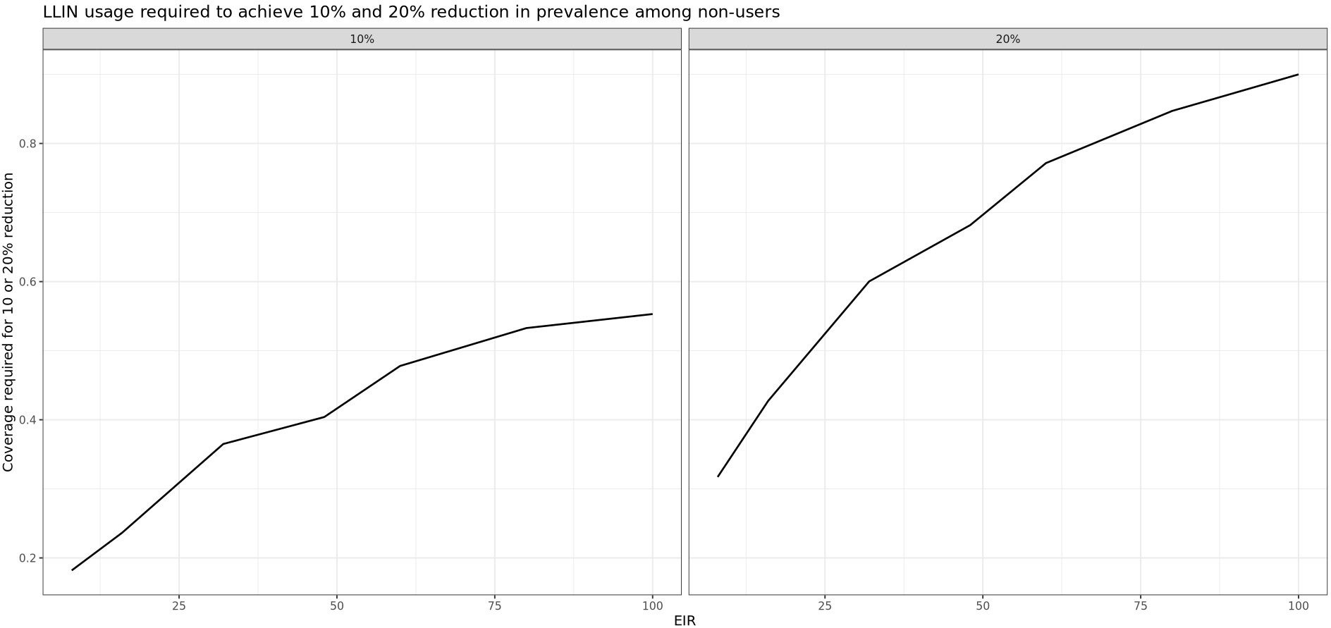
Our results suggest that achieving a 10% reduction in prevalence among non-users requires LLIN usage of 18 - 55% depending on transmission intensity, while a 20% reduction was only achievable at low-to-moderate EIR

- Benefit/impact per net deployed => any plateau of additional benefit at some level of coverage?
  - At which coverage do we maximize the difference or ratio between prevalence reduction in overall vs prevalence reduction in users only?

- nInfect (The number of human hosts with an infection (patent or not) on the reporting timestep) for 0-100 is high in users but normal in u5
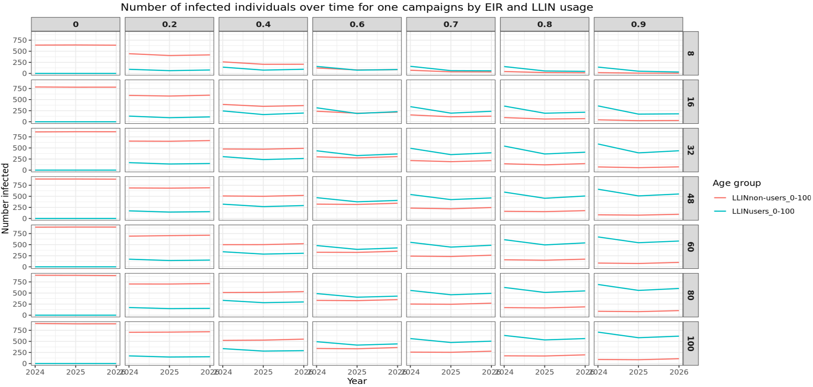
- innoculationsPerAgeGroup (The total number of inoculations per age group, summed over the reporting period. (Units are not adjusted to account for reduced child availability to mosquitoes.)) – 0-100
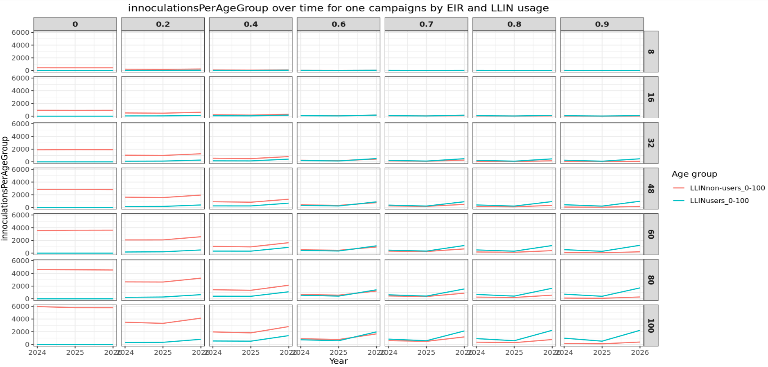
- why are the prevalence reductions higher in non-users for high coverage
Answer: immunity amongst non-users

other to do (new simulation):
- add 5 & 10 % coverage to the simulations
- new bed net parameterization
- look at other intreventions

18-12-2025: Meeting with Emilie and Christian – Feedback and Todo
- do lit review and identify the gap
- write manuscript draft

- Christian: Inoculation/infected (as number of inoculation needed to create one infection) in
A) simulation without bednets R_A
B) simulation with bednets, but having the ratio for users R_B1 and non-users R_B2...
Comparing R_A vs R_B2, if they are the same, the benefit of decreasing EIR through bednets and having more immunity experienced in non-users should even out, if not, then we would like to understand whether R_B2 is benefiting more from decreases EIR or increased immunity (compared to non-users)..
ANSWER
- New simulation without bednets R_A – using CM only_nInfect simulation as R_A
- simulation with bednets – filtering one coverage level (90% to have same non-users as no LLIN data)- R_B1 for users, R_B2 for non-users
- use same simulation and filter 0-cov as R_A, and split 60% -cov for both LLIN users (R_B1) and non-users (R_B2). But this means the R_A uses the whole pop whiles R_B1 and R_B2 use fractions of the population.
How many infectious bites are required, on average, to produce one established blood-stage infection?
- Low ratio (~1) → almost every infectious bite leads to infection
- High ratio (>1) → many bites are “wasted” before one infection establishes
The ratio captures host-level resistance to infection, which in malaria is driven largely by acquired immunity
Higher inocc_infect_ratio = higher effective immunity
- Immune system clears parasites before blood-stage infection
- More bites needed per infection
- Lower susceptibility
Lower inocc_infect_ratio = lower immunity
- Each bite more likely to establish infection
- Higher susceptibility
The ratio of inoculations to infection represents the number of infectious bites required to generate one blood-stage infection, and therefore serves as a proxy for host-level resistance to infection driven by acquired immunity 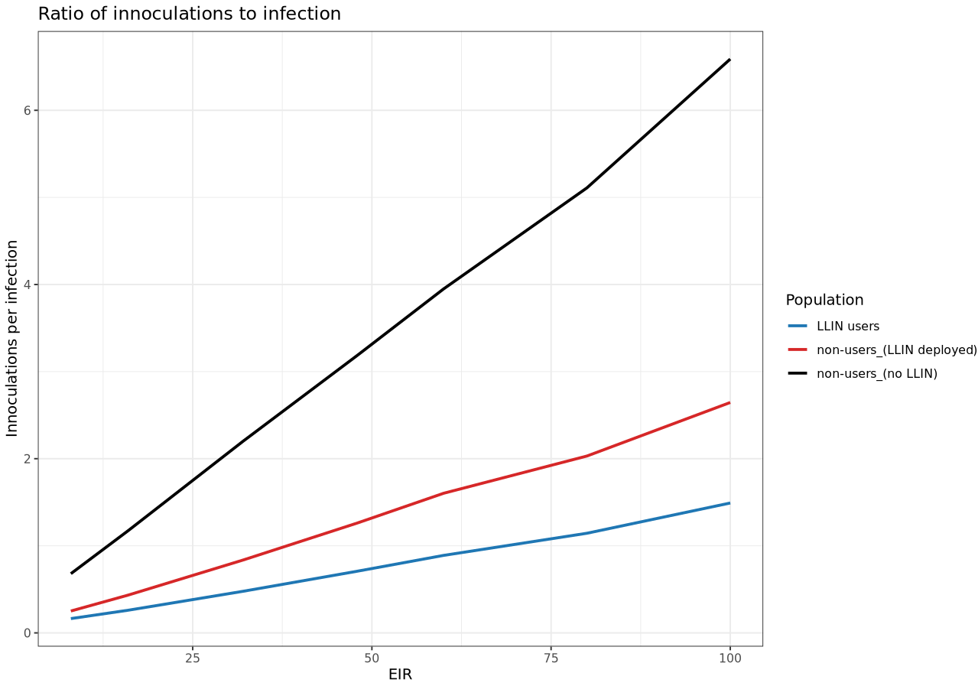
9-01-2026 – meeting with Christian
trade-off between acquired immunity and intervention coverage maybe: contour plot for non-users cohort
x-axis coverage of itn (20,40,60,80%) [effective coverage with ITNs]
y-axis inocc_infect_ratio [acquired immunity]
z axis prevalence reduction [epi outcome]
- new bednet parameterization
How much community protection is needed to compensate for reduced immunity among non-users?

